ONTLAMETSE MOGAPI

PROG6212 POE PART 3

ST10244738

Documentation and screenshots

**Contract Monthly Claim System (CMCS) Documentation**

**1. Introduction**

The **Contract Monthly Claim System (CMCS)** is a .NET-based web application developed to streamline the process of submitting, reviewing, and approving monthly claims for Independent Contractor Lecturers. The system provides tailored interfaces for Lecturers, Programme Coordinators, Academic Managers, and the HR department, enabling automation and efficient management of claims.

**2. Project Overview**

* **Technology Stack**:
  + Backend: ASP.NET Core MVC
  + Frontend: Razor Pages, Bootstrap
  + Database: SQL Server with Entity Framework Core
  + Authentication: ASP.NET Identity
  + Reporting: iTextSharp library for PDF generation
* **Key Features**:
  + Automated calculation of payments based on hours worked and hourly rates.
  + Validation of claim data during submission.
  + Workflow for reviewing and approving claims.
  + HR functionalities for managing lecturer data and generating claim reports.
  + Role-based authentication for secure access.

**3. Features and Functionalities**

**Lecturer Interface**

* Submit claims by entering hours worked, hourly rate, and a description of the work performed.
* Upload supporting documents (e.g., PDFs).
* View the status of submitted claims (Pending, Approved, or Rejected).

**Programme Coordinator & Academic Manager Interface**

* Review submitted claims.
* Approve or reject claims based on predefined criteria.
* Add comments to approved/rejected claims.

**HR Interface**

* View approved claims and generate detailed summary reports.
* Manage lecturer information (e.g., update personal details).
* Generate PDF reports for administrative purposes.

**4. Database Design**

**Tables:**

1. **Users**:
   * Stores lecturer, coordinator, and HR details.
   * Fields: UserId, Name, Email, Role, PasswordHash.
2. **Claims**:
   * Records all claim submissions.
   * Fields: ClaimId, LecturerId, HoursWorked, HourlyRate, FinalPayment, Description, Status, DateSubmitted, DateApproved.
3. **Lecturers**:
   * Stores lecturer-specific details.
   * Fields: LecturerId, Name, Email, Contact, Department.

**5. Validation and Error Handling**

* Input validation using client-side JavaScript and server-side FluentValidation.
* Detailed error messages for failed database operations or invalid inputs.

**6. Deployment**

* Hosting: Deployed on Microsoft Azure.
* Database: Azure SQL Database.
* CI/CD: GitHub Actions for automated builds and deployments.

**7. Conclusion**

The Contract Monthly Claim System automates the claim submission and approval process, reducing administrative burdens and ensuring accuracy. The inclusion of HR-specific functionalities further streamlines payroll processing and lecturer management, making the system a valuable tool for the institution.

**Screenshots**

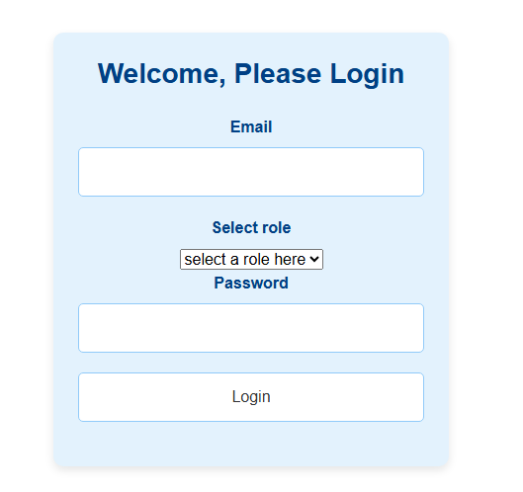

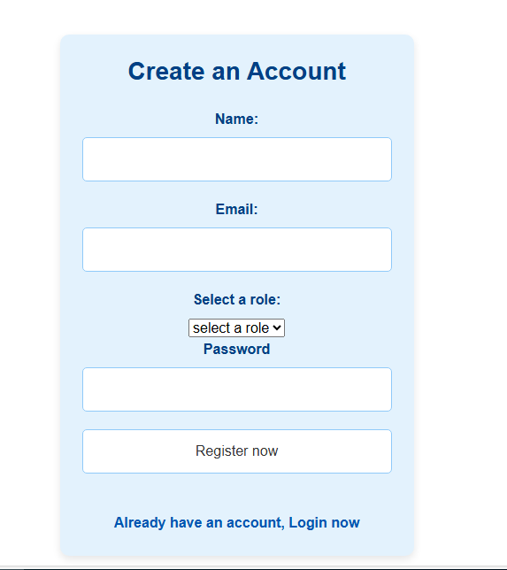

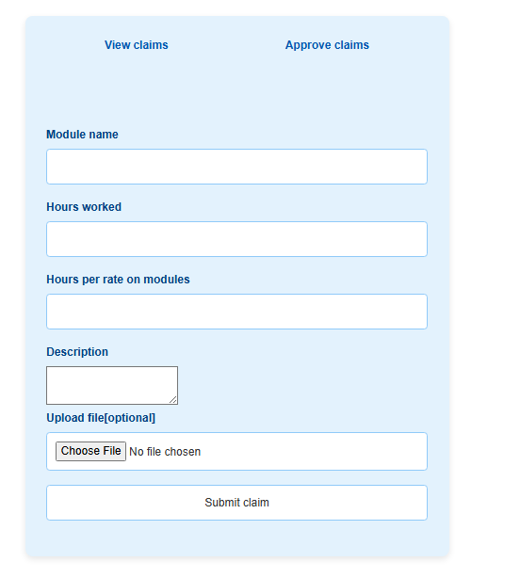

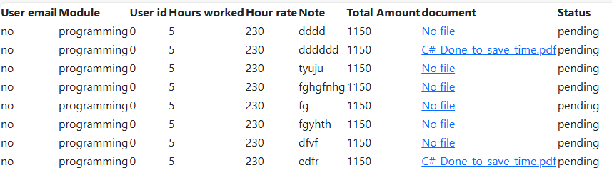

Github screenshot. Link: <https://github.com/ST10244738/PROG6212-Part-3.git>

